**CH 245: ORGANIC CHEMISTRY I LABORATORY (Fall 2019)**

**Title:**

1. **Purpose: (1 point)**

**The purpose of this lab is to synthesize nylon 6,10.**

1. **Drawing of structure of the main compound or balanced chemical equation if synthesis is performed: (1 point)**

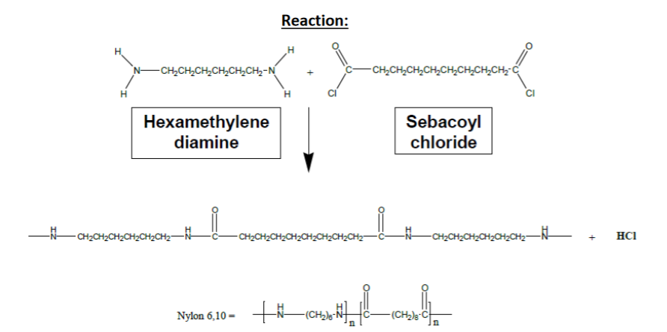

**3. Reagents and the major product (up to 5 points)**

|  |  |  |  |  |  |  |
| --- | --- | --- | --- | --- | --- | --- |
| **Name** | **M.W.**  (0.5 pts) | **Density**  (0.5 pts) | **Amount (grams/mL)**  (0.5 pts) | **Moles**  (0.5 pts) | **Hazards/Precautions**  **(MSDS data) and melting point or boiling point** (2 pts) | **Role of the reagent\*** (1 pts) |
| Hexamethylene Diamine | 116.21 | 0.84 g/mL | 0.45 grams | 0.00387 | Severe skin burns, eye damage, may cause respiratory irritation. | Reactant |
| Sebacoyl Chloride | 239.14 | 1.121 g/mL | 0.4 mL | 0.00188 | Severe skin burns and eye damage | Reactant |
| Hexane | 86.18 | 0.659 g/mL | 20 mL | 0.153 | Highly flammable, skin and eye irritation | Solvent |
| Acetone | 58.08 | 0.790 g/mL | N/A | N/A | Highly flammable, serious eye irritation | ---- |
| Sodium Hydroxide | 40.00 | 2.13 g/mL | 10 mL 3% solution | 0.0075 | Eye and skin burns, severe respiratory irritation | Solvent |
| Nylon 6,10 | 318.452 | 1.04 g/cm3 | .599 grams | 0.00188 | Not hazardous | Product |

**For Role of the reagent*, Choose from the following options:**

**Reactant, Product, Solvent, Drying agent, Catalyst**

**4. Calculations: (1 point)**

Show each calculation for moles of reagents and for theoretical and actual yield. Fill in the box with the limiting reagent and theoretical yield:

Sebacoyl Chloride

The limiting reagent is

0.599 grams Nylon 6,10

The theoretical yield is

$$0.00188 mol Sebacoyl Chloride*\frac{\text{1 mol Nylon 6,10}}{\text{1 mol }\text{Sebacoyl}\text{ Chloride}}*\frac{\text{318.452 g Nylon 6,10}}{\text{1 mol Nylon 6,10}}=\text{0.599 g Nylon 6,10}$$

**5. Procedure (up to 2 points)**

|  |  |
| --- | --- |
| **Procedure** | **Observations and Lab Data** |
| A summary of the procedure done with bullet points) | Color changes, exothermic or endothermic reactions, gas generation, etc.; tare weights for flasks, etc. |
| * Dissolve 0.4 mL sebacoyl chloride in 2 mL of hexane in beaker. * Dissolve 0.45 g hexamethylene diamine in 10 mL 3% sodium hydroxide solution in 50 mL beaker. * Pour sebacoyl chloride solution over diamine solution carefully and slowly over end of a funnel or glass rod to minimize splashing. Do not stir or mix abruptly. * Use clean forceps to pick one string from the film that forms. * Wrap thread-like string around a glass rod and spin rod until there is no more nylon left. * Remove the spool of thread and dry between two clean paper towels or filter paper. * Set up a vacuum filtration and wash thread with water 3 times. * Wash once more with acetone and set to dry. * Record mass and calculate % yield. |  |

**6.** Results; include actual yield in grams and % yield.

**Results (need to get signed by instructor or TA):**

**1.39 grams Nylon produced**

**1.39 g / 0.599 grams = 232% yield**

**Conclusion**

I **accomplished** a synthesis of Nylon 6,10 from sebacoyl chloride and hexamethylene diamine. Through this lab, I **learned** about the process to produce organic polymers and about the properties of polymers. However, an **issue** I had during the experiment, or rather, after it, was that I was not able to allow the nylon to completely dry, so I got a measured percent yield much higher than the theoretical yield. Thus, **next time** I do the experiment, I will make sure to dry out the nylon completely before weighing the product. The **practical application** of this experiment is to produce strong, stable polymer compounds that have many applications in the real world, such as nylon clothing.

**Post Lab Questions**

The sodium hydroxide acts as a nucleophile to deprotonate the nitrogen from hexamethyl diamine after it reacts with sebacoyl chloride.

